Ministry of Health
National Public Health Laboratories
Kenya External Quality Assessment Scheme (KNEQAS)

Instructions on Appropriate Transportation of PT Material to Participants

Applicability:

  - Distributing agency (from KNEQAS to participants/regions)

  - Sub county QA officers (from Sub-county offices to participants) – Where applicable
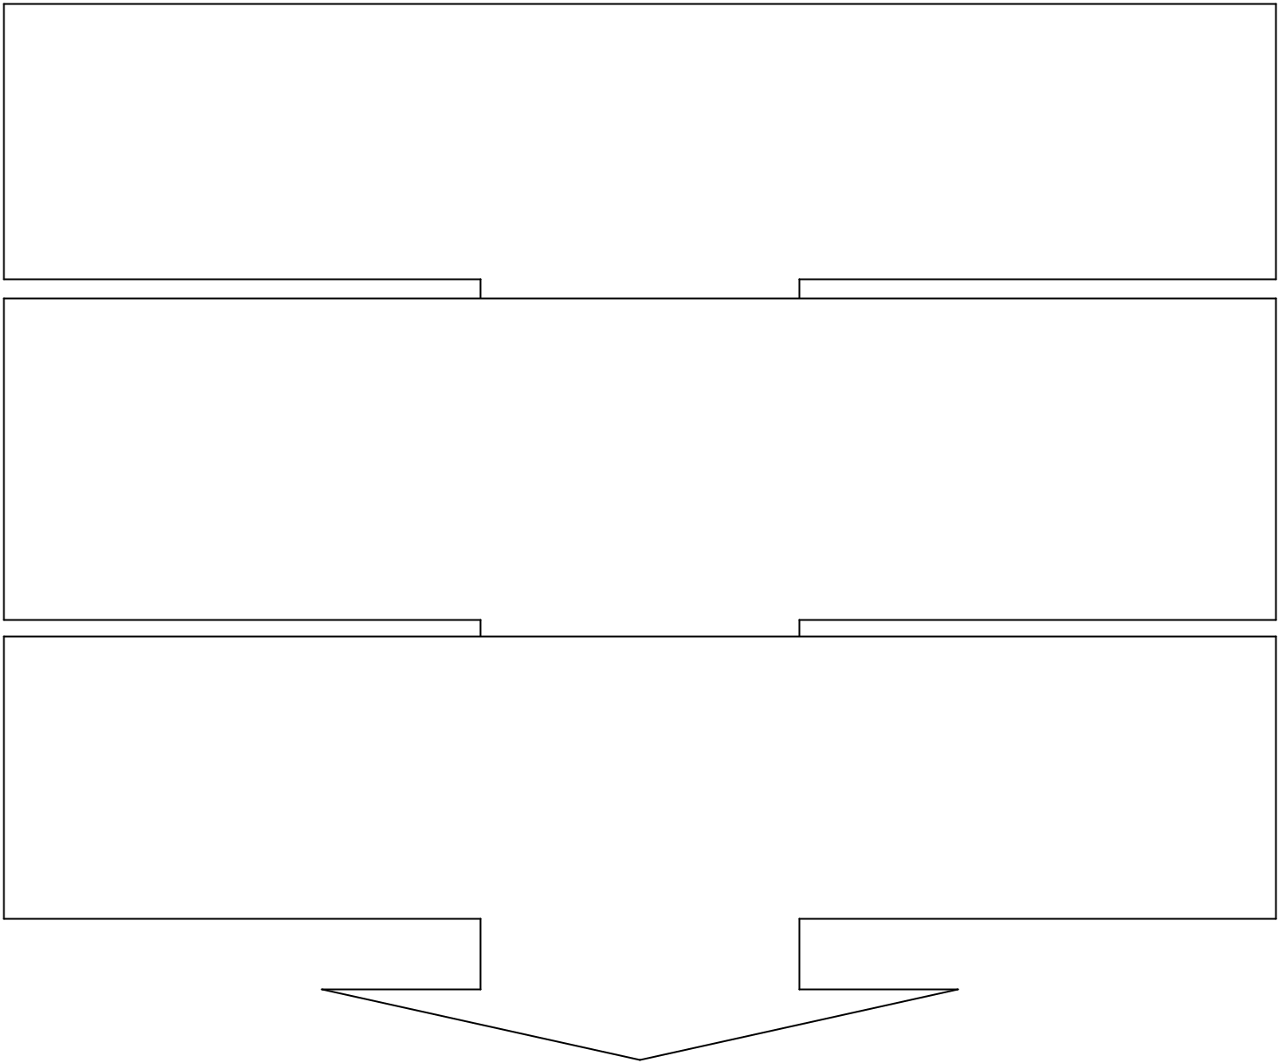
- Collection of PT material from KNEQAS
Confirm that:
  - Documented content corresponds with parcel content
  - Parcels are well Packaged (rigid boxes and sealed)
  - Parcels are labeled well (Clearly addressed, bio-hazard mark in place, transportation temperature indicated)

- Transportation from KNEQAS to participants/ sub county QA officers

  - Handle as if fragile
  - Maintain in packaging material through-out
  - Transport in temperature conditions indicated on label
  - Deliver to addressee without undue delay
  - Document proof of delivery

- Transportation from Sub- county to participants (Health facility)- where applicable

  - Sort out panels per facility.
  - Deliver panels to participants’ facilities without undue delay.
  - Document and maintain proof of delivery.
  - Communicate to KNEQAS in case of any issues of concern eg (missing panels).

Contacts for enquiries
All inquires, compliments, comments, assistance can be channeled through any of the below contacts
Kenya External Quality Assessment Scheme (KNEQAS)  National Public Health Laboratories  Kenyatta National Hospital Grounds  P.O Box 20750 – 00202 , Nairobi | - KNEQAS Email – nphlpt@nphl.go.ke  - Scheme Coordinator/Manager - 0721397766  - Scheme data manager – 0721825737.  - KNEQAS Help desk at… http://helpdesk.nphl.go.ke/

